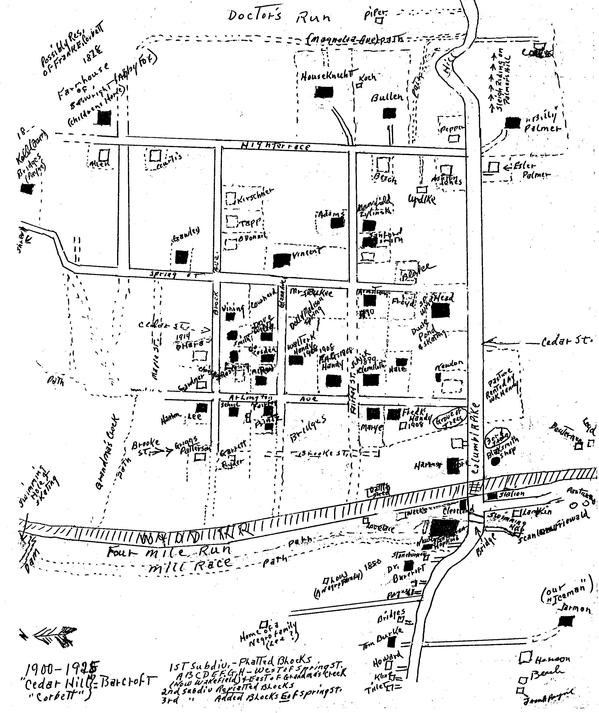

Barcroft in 1915 - 1921 Houses blacked in were in place in 1915.

Mildred Handy Ritchie’s Map

